Bellingcat Open Source / Digital Research Training Workshops

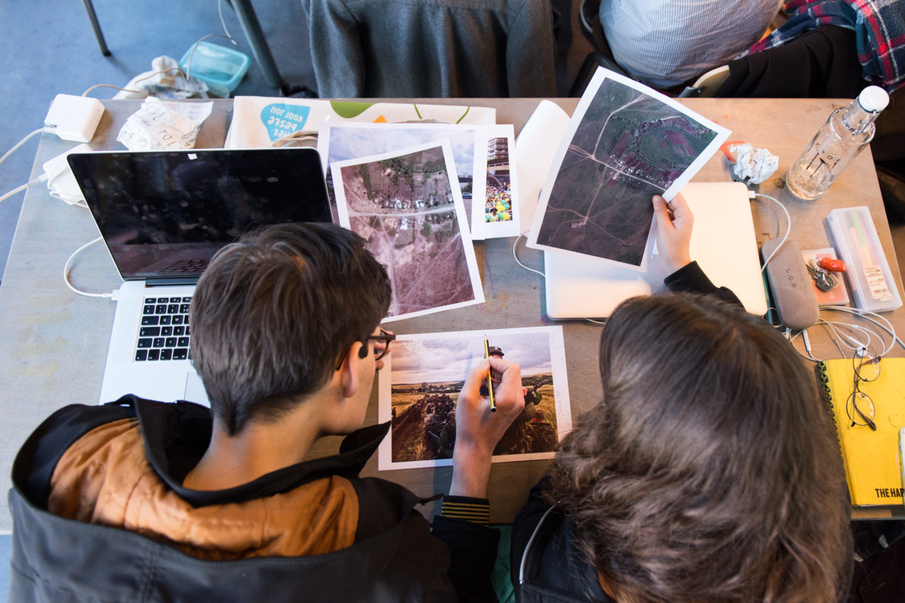
Bellingcat workshop participants hard at work at the Royal Academy of Art at The Hague (Wouter Stelwagen / kabk.nl)

Bellingcat offers training in open source and digital research techniques in both English and Russian (along with other languages in limited capacities) during multi-day workshops around the world. Most often, we hold these workshops in major cities in western and central Europe, the United States, and Canada, but also regularly hold three-day Russian-language workshops free of charge in Central Asia and the Caucasus.
Our five-day workshops are held for approximately 20 participants with at least two Bellingcat trainers present throughout the workshop. These trainings introduce a number of research and verification techniques to our participants, with an emphasis on hands-on practice and presentation of various case studies. The first three days are heavy on introducing key methodologies and concepts in digital research with hands-on exercises and case studies. For example, when discussing geolocation of photographs and videos, Bellingcat trainers will describe how to carry out this methodology from a beginner’s level up to difficult exercises, along with providing a range of examples of this technique being used in various investigations across different international contexts.
The two final days of the training are focused on projects, in which participants work either alone or (preferably) in small groups with the assistance of Bellingcat trainers to tackle a problem that can be approached from a digital angle. These two days allow participants to use techniques discussed during the workshop and to work with Bellingcat’s trainers to get more practice and guidance with specific methods and skills that they need for their own work. We encourage participants to pick subjects that can be investigated in the two-day period, with some previous successful examples during workshops including:
- Investigating the bombing of al-Jinah mosque in Syria by US coalition forces,
- Examining social media profiles of illegal amber miners in Ukraine,
- Geolocating footage of the destruction of a mosque by ISIS in Mosul,
- Setting up a virtual Android device on a laptop to anonymously install and use mobile dating apps to conduct open source research on individuals in sensitive locations.
If participants cannot think of projects ahead of the time, this is no problem – often, events during the workshop will provide inspiration for projects.

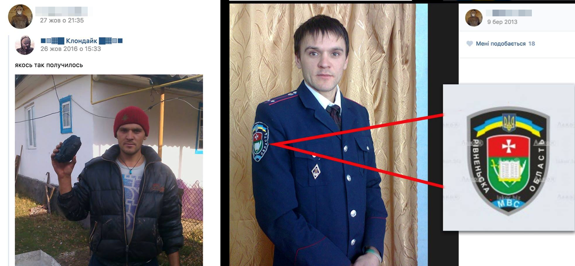
Example of the findings during a Bellingcat workshop, in which a Ukrainian police officer was found to be participating in illegal amber mining from his social media posts

General Training Outline (First three days)
No Bellingcat workshop is exactly the same, as we often change our examples and exercises to fit the interests and needs of our participants—for example, we may replace a segment focusing on using satellite imagery for one on conducting geo-based searches in Instagram on the fly, if participants find it more useful. The length of the segments is also dependent on the participants—for example, we may extend a segment if participants want more information/practice or are having trouble mastering skills. We have approximately 40 hours of exercises, case studies, and presentations ready in both English and Russian for our workshops, and can rotate out material as needed.
In general, there are three basic themes that are set up on each day: verification (day one), geo-based searches and visual investigations (day two), and social media research (day three). Days four and five are focused on project work with guidance from Bellingcat trainers.

Day 1:

Morning -
- What is Bellingcat?
- What is online open source investigation, and what can be done with it?
- General search techniques and verification principles (beyond just “advanced Googling” and reverse image searching – how do you approach digital research and verification, and how do these approaches differ depending on profession and region?)
- Image and video verification (heavy focus on geolocation and time determination)
Afternoon -
- Image and video verification (heavy focus on geolocation and time determination)
- In-depth exercise on verification of specific events (exercise differs depending on participants)

Day 2:

Morning -
- Geo-based searches (how to find photos/videos associated with particular locations on general sites / social networks)
- Satellite images and map services and resources (how to find, use, assess satellite imagery, pros and cons of various services)

Afternoon -
- How to conduct a comprehensive investigation based on visual materials (when working with a large number of photographs and videos, what are the best practices for collecting, analyzing, and verifying such a large amount of information?)
- In-depth exercise on visual investigations (exercise differs depending on participants)
Day 3:

Morning -
- Detailed information on conducting comprehensive searches for information on individuals and groups online (includes both social network-focused searches and the rest of the internet, including often overlooked sources of information)
- Case study and guided exercises on finding information on a research subject (example differs depending on participants)
Afternoon -
- Advanced Facebook search
- Corruption-focused databases and resources

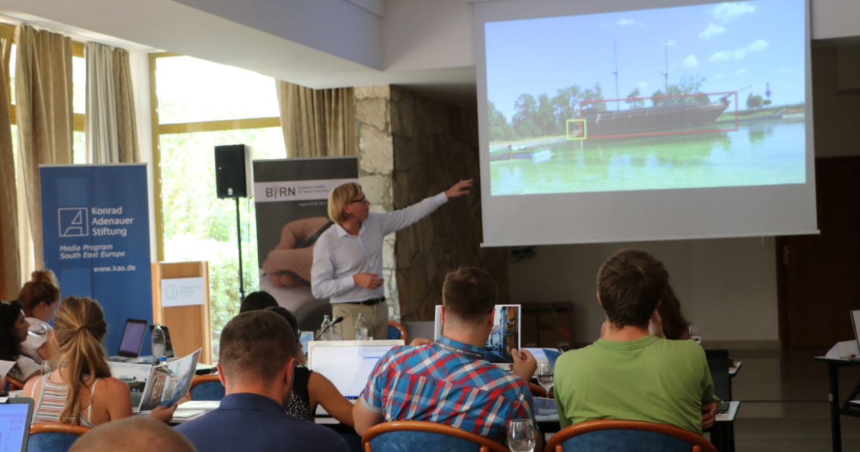
Bellingcat trainer Christiaan Triebert leading a lecture on geolocation in Dubrovnik, 2017
Frequently Asked Questions

Who normally participates in Bellingcat’s workshops?
The majority of our workshop attendees are journalists, human rights researchers and advocates, staff at private research firms, and/or employees at tech companies. The most common goal that our participants voice to us about what they are looking for learning in trainings is how to conduct online investigations with a focus on sources from social networks, along with help in conducting analysis and verification on visual materials (for example, user-generated videos and satellite imagery).

What language is the workshop in?
Nearly all of our workshops are led entirely in English. We often run Russian-language workshops in the Caucasus and Central Asia, along with Spanish-language workshops in Central and South America, but these are explicitly noted as such in our workshop announcements. We have a number of language proficiencies among our trainers, but all of our materials and case studies are in English, Spanish, or Russian. If you are interested in having a workshop ran in a different European language in which our trainers are fluent (e.g. Dutch, German, French), send a message to workshops@bellingcat.com with more information, and we will see if we can make something work.

How advanced are your workshops?
We would say that our workshops require an intermediate level of proficiency with online and digital research. Participants who have attended numerous digital and open source workshops may not learn a lot of new techniques during our workshops, but may find the case studies and one-on-one work with our trainers useful. Participants who are not very technically proficient (e.g. are not familiar with how to use social networks or online mapping/satellite services) may have a hard time keeping up with our trainings. That said, the majority of people who have participated in our workshops have been at about the right level—fairly digitally savvy and with some experience doing online research, but not necessarily experts or masters of verification and social network digging.
During our workshops, we do not put a heavy emphasis on teaching topics that require advanced training and experience, such as writing scripts for scraping data or automating tasks. We focus more on teaching investigative processes and methodologies that do not require pre-existing mastery of a coding language (e.g. Python) or expensive application (e.g. Maltego XL), though many of our trainers are proficient in writing scripts or using these tools.

What do I need to bring with me to a workshop?
Just a laptop, preferably with Google Earth Pro installed (free and easy to install on Windows, Mac, and Linux). You should also have a Facebook account available during the workshop, as many of the exercises require the participant to be logged in. This Facebook login can be either a “dummy account” or your real, personal account. Some participants have had success in using tablets at workshops, but many have hit roadblocks during some exercises, so we would recommend bringing a laptop if possible.

Are government employees allowed at Bellingcat’s workshops?
Maybe. With rare exceptions, we do not allow members of government intelligence agencies or militaries attend any of our workshops for a number of reasons, one of which is that our other participants may not feel comfortable with their presence. For other government entities, we consider requests on a case-by-case basis—our team will often have internal discussions on whether we feel comfortable both morally and ethically in providing training to particular organizations and governments. We can make exceptions in some cases – for example, we may be comfortable with allowing an archivist working for a country’s ministry of defense to attend, but we would not allow an intelligence specialist from that same ministry.

Wow, it’s really expensive to attend a workshop! [2200 EUR/participant)
It is! While our trainers occasionally hold workshops for free with non-profit groups or at public events, most of our trainings – specifically, our five-day workshops – are quite expensive. We charge this rate because, for one, we have filled nearly every available seat for each of our paid workshops since we began offering them, so the demand fits the price. Along with that, for similar open source and digital training workshops, the fees for other groups providing roughly similar experiences is far more than ours—sometimes double, triple, or more our price. Additionally, as we have very little overhead costs at Bellingcat, nearly every dime of the money we raise for our workshops goes directly to hiring and paying the salaries of our investigators and trainers. We try to publish as many publicly-available online guides as possible to assist those unable to attend our workshops due to financial or geographic restrictions.

I’d like to have a workshop held specifically for my company / organization – how can I arrange this?
Please send a request to workshops@bellingcat.com with details on the approximate date and location of your proposed workshop. In general, we require at least fifteen paid participants at a workshop held for one organization, with a minimum of three days of training. Alternatively, if we are interested in staging a training in the city of an interested organization, we often hold a workshop at a venue provided by an organization in exchange for the host receiving three free seats at the workshop.

Where do you normally hold Bellingcat workshops?
Bellingcat trainers have held workshops at dozens of cities and countries since 2014, but have held or will soon hold self-organized five-day workshops in the following cities (in approximate order of frequency): London, Amsterdam, Washington D.C., New York, San Francisco, Berlin, Toronto, Zurich, Paris. By far the greatest demand for workshops is in Amsterdam, London, Toronto, and Washington D.C. We also regularly hold three-day, Russian-language workshops at reduced or no cost in Tbilisi, Bishkek, Yerevan, Almaty, and Kyiv.

